**Divya Shah**

**2019130057**

**TE Comps**

**Batch C**

**Experiment 2: Traditional Crypto Methods**

**Aim:**

**To implement Diffie Hellman Key Exchange Algorithm.**

1. **Diffie Hellman**

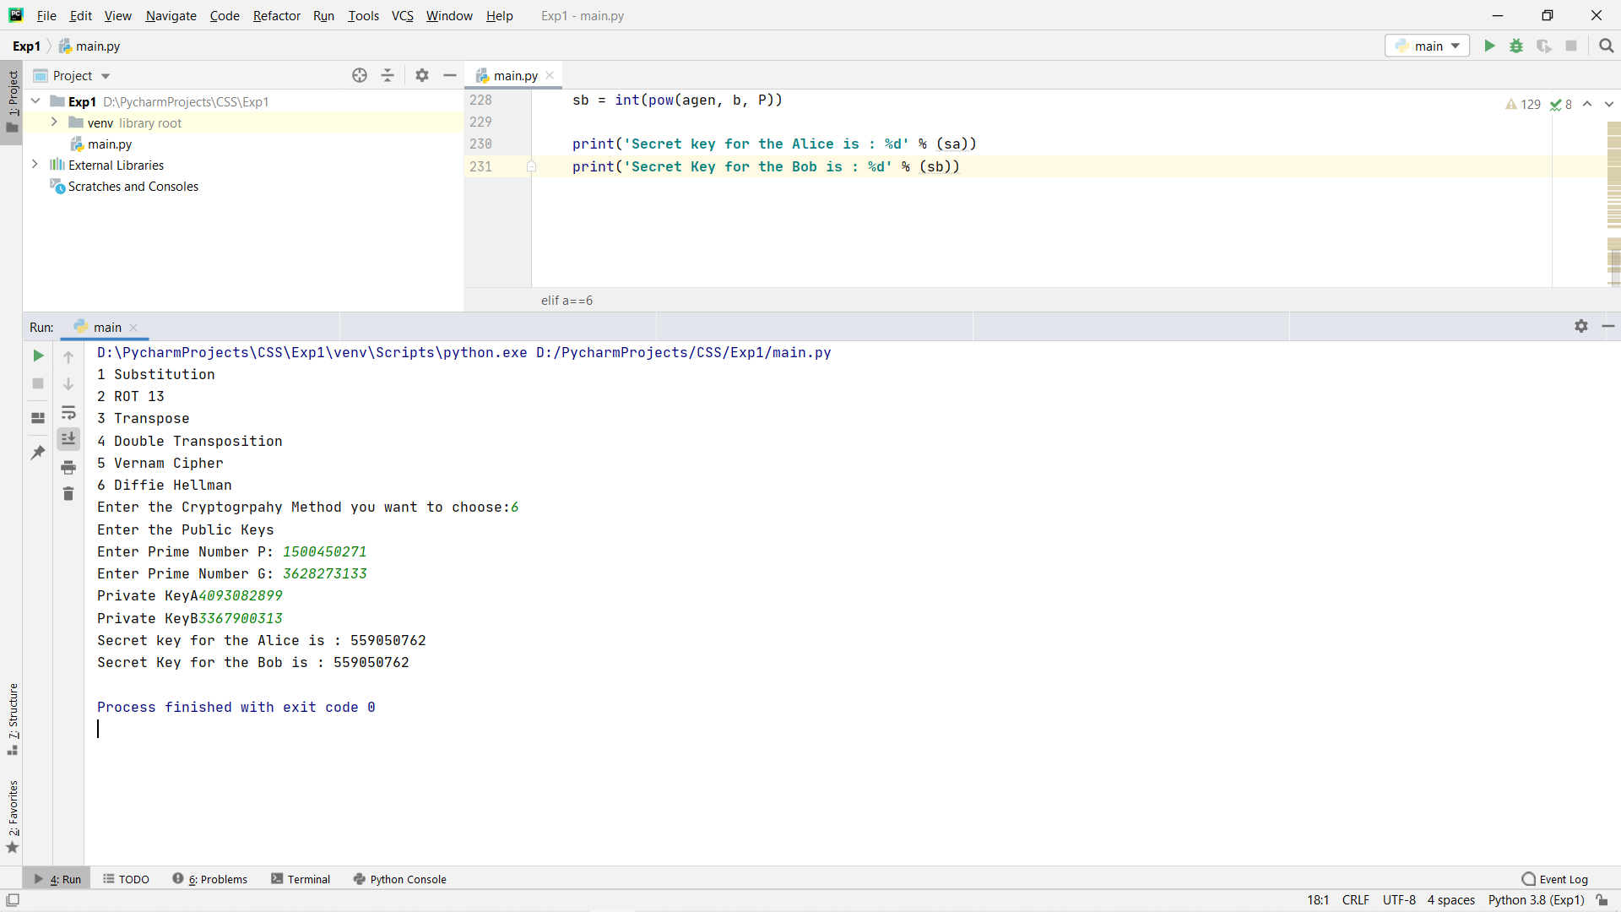

**Conclusion:**

Diffie Hellman is a safe key exchange algorithm for secret communication on public platform. It makes possible for two parties to agree on a secret key with giving away key information openly. Diffie Hellman is computation intensive for higher data in terms of resources and CPU Power.

Github Link:

<https://github.com/Divya-127/CSS-Lab/tree/main/Exp2>